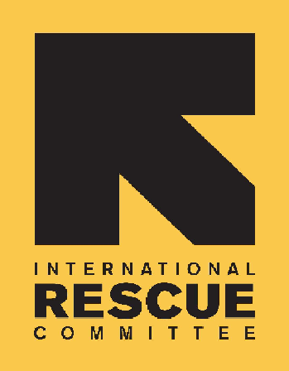
INTERNATIONAL RESCUE COMMITTEE, INC.

BID NOTICE

Founded in 1933, the International Rescue Committee is a global humanitarian leader that help people whose lives and livelihoods are shattered by conflict and disaster to survive, recover, and gain control of their future.

The IRC is currently working in Damazine, Gedarif, South Kordofan, White Nile, Port Sudan and River Nile state.

The regular sectors in IRC Sudan are Health, Environmental Health, Child Protection, Women Protection & Empowerment, Economic Recovery & Development.

The IRC is issuing Request for Proposals (RFPs) to solicit competitive sealed bids to establish a long-term agreement with reputable companies for the Provision of the following goods and services.

No: Good/Service |  | Category ID #:
 | - Non-Food Items (NFI) (MPA)  - Office Supplies and Cleaning items (MPA)  - Stationery and Office equipment (MPA)  - Customs Clearance Services (MSA). | IRC/SDN/MPA/2024/03  IRC/SDN/MPA/2024/02  IRC/SDN/MPA/2024/01  IRC/SDN/MSA/2024/01
Interested and suitably qualified Vendors may request for complete tender documents (RFP) from
SU-KhartoumProcurementrescue.org during office hours 8:00AM to 4:00PM. Or download complete documents from the Sudan bids website directly.

Please quote the category ID# as the subject of your e-mail.

DEADLINE for all Bidders to submit completed bid documents is Sunday, 3rd of June 2024 at 4:00pm Sudan time.

